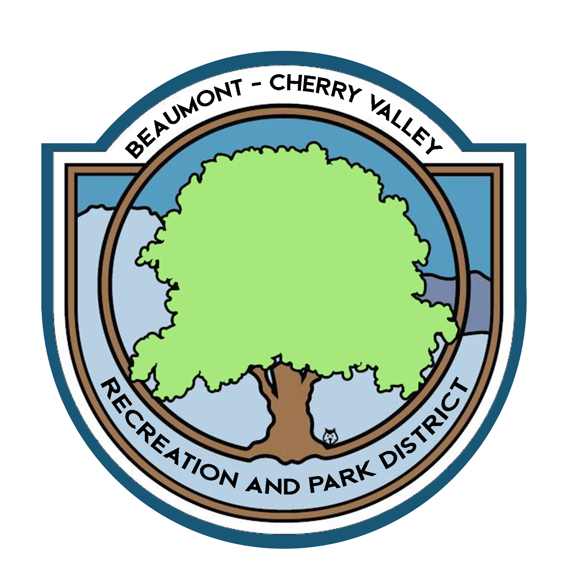

BEAUMONT CHERRY VALLEY RECREATION & PARK DISTRICT
FINANCE COMMITTEE MEETING
Thursday, July 8th, 2021
390 W. Oak Valley Parkway Beaumont, CA 92223

MINUTES
www.bcvparks.com

REGULAR SESSION: Regular Session to Begin at 5:10pm

Roll Call:
Vice Chair/Secretary Diercks __X___ Treasurer Flores__X___ General Manager Burk _A_ Financial Services Technician/Office Manager Law __X___

Adjustments to Agenda: None

- PUBLIC COMMENT: None

- CONSENT CALENDAR:
- 2.1 Minutes of Thursday, June 3rd, 2021. Motion was made to approve minutes by Chris Diercks 2nd by John Flores

- ACTION ITEMS
- 3.1 Financial Report June 2021 Motion was made to approve the finance package as submitted by John Flores 2nd by Chris Diercks.
Passed unopposed

- 3.2 Check Warrants June 2021 Motion was made to approve the check warrants by John Flores 2nd by Chris Diercks.
Passed unopposed

- 3.3 Riverside County Fund Request of $200,000.00 (Bills & Payroll) Motion was made to approve the request of $200,000.00 from the Riverside County Fund by John Flores 2nd by Chris Diercks.
Passed unopposed

- DISCUSSION:
  - 4.1 Reviewed 1K/5K, Spring Fling & Fishing Derby Profit and Loss no questions were asked.

  - 4.2 Reviewed Bogart Income sheet, Treasurer Flores and Vice Chair/Secretary Diercks were very pleased to see an increase of income at Bogart after opening for fishing.

  - 4.3 Reviewed FY20/21 Monthly Operating Totals, Treasurer Flores and Vice Chair/Secretary Diercks wanted to discuss changing the monthly operating reserves.

- ADJORNMENT:
The meeting was adjourned by John Flores at 5:48pm

